CIS PROJECTS TABLES

City_Master Table:

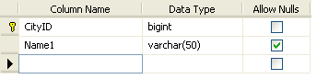

Comm_Mast Table :

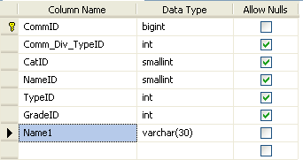

Comm_Price Table:

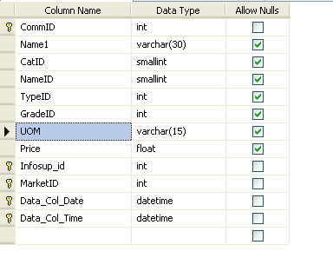

COMM_UNIT Table:

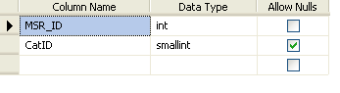

Cust_Mast Table :

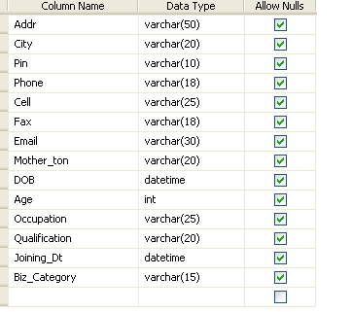

Info_Supplier Table :

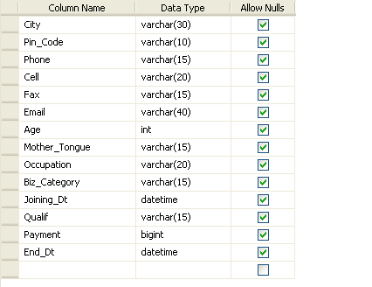

Loc_Mast Table:

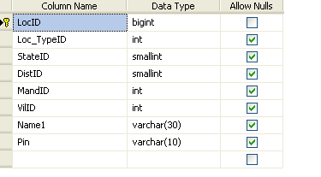

Login_Form Table:

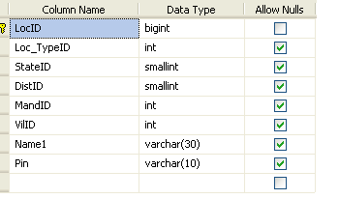

Market_Comm Table:

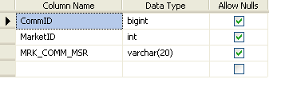

Market_Mast Table

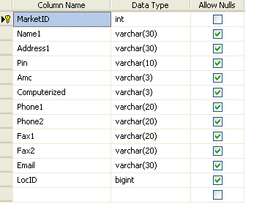
UOM_Mast Table:

